https://doi.org/10.1016/j.foodres.2019.108610
Comprehensive approaches on the chemical constituents and pharmacological properties of ﬂowers and leaves of American basil (Ocimum americanum L)
Gokhan Zengin, Claudio Ferrante, Diane Estelle Gnapi, Kouadio Ibrahime Sinan, Giustino Orlando Lucia Recinella, Alina Diuzheva, József Jekő, Zoltán Cziáky, Annalisa Chiavaroli, Sheila Leone, Luigi Brunetti, Carene Picot-Allain, Mohamad Fawzi Mahomoodally, Paola Angelini, Stefano Covino, Roberto Venanzoni, Bruno Tirillini, Luigi Menghini

Ocimum americanum L. (Lamiaceae) is a common food condiment and also used in traditional medicine in the management of several human diseases. Nonetheless, there has been no eﬀort to delineate the biological and phytochemical proﬁles of leaves and ﬂowers prepared by diﬀerent extractive solvents (ethyl acetate, methanol (MeOH), and water). The pharmacological potential of O. americanum extracts on pro-oXidant/pro-inﬂammatory mediators in rat colon specimens treated with lipopolysaccharide was investigated. In parallel, the inhibitory eﬀects of the extracts on fungal and bacterial strains involved in ulcerative colitis were studied. Qualitative phytochemical analysis showed the presence of phenols, ﬂavonoids, and tannins. Water extracts of ﬂowers and leaves showed strong reducing and radicals scavenging potential. Both MeOH and ethyl acetate extracts of the leaves and ﬂowers were able to inhibit acetylcholinesterase, butyrylcholinesterase, and tyrosinase. All the ex- tracts inhibited the selected bacterial and fungal strains, while only ethyl acetate ﬂower extract displayed an- tioXidant/anti-inﬂammatory eﬀects in rat colon. The water and MeOH extracts stimulated colon lactate dehy- drogenase (LDH) and serotonin (5-HT) and induced spontaneous migration of HCT116 cells. Future investigations should focus on the biological activity of isolated phytochemicals from the leaves and ﬂowers of
O. americanum, in order to clarify the mechanism(s) of action substantiating the observed pharmacological
properties

.

Ocimum americanum L. (Lamiaceae), also known as American basil or ‘Hoary basil’ forms part of the Ocimum genus, which comprises of > 150 species distributed throughout temperate regions of the globe (Dzoyem, McGaw, Kuete, & Bakowsky, 2017). The aromatic leaves of O. americanum can be used as condiment (Aluko, Oloyede, & Afolayan,

2013). For instance, it used in the preparation of soups (Bassole et al., 2005), while the seeds can be used to prepare refreshing drinks (Upadhyay, Misra, & Singh, 1991). In traditional medicine, the leaf juice of O. americanum is used to manage dysentery, toothache, and migraine (Ekundayo, Laakso, & Hiltunen, 1989; Sen & Behera, 2008; Silva et al., 2015; Sunitha & Begum, 2013). A decoction of the leaf has been documented to be used against nasal bleeding and malarial fever

(Shah & Rahim, 2017; Sunitha & Begum, 2013). A paste obtained from the leaves was also used against skin diseases of parasitic origin (Leﬀers, 2003). On the other hand, an infusion prepared from the leaves was used to treat fever, indigestion, and diarrhoea (Aluko et al., 2013; Oyedemi et al., 2017). O. americanum is also used for the management of cold, coughs, cataract, and bronchitis (Oyedemi et al., 2017; Pandey, Chandra, Kumar, Dutt, & Sharma, 2016; Sunitha & Begum, 2013). Pharmacological evidences have shown that the crude methanol extract of O. americanum leaf exhibited synergistic interaction with norﬂoxacin against Staphylococcus aureus strains and showed non-toxic eﬀect on the
HepG2 cells (IC₅₀ value 378.0 μg/mL) (Oyedemi et al., 2017). O. americanum leaf methanol extract has been reported to be an eﬀective
larvicidal and repellent agent against malarial and dengue vectors (Madhiyazhagan, Murugan, Kumar, & Nataraj, 2014). Essential oil ob- tained from fresh O. americanum leaves by hydrodistillation showed antioxidant and cytotoxic (breast cancer cell line, MCF-7) activities (Tamil Selvi, Thirugnanasampandan, & Sundarammal, 2015). Diabetic and non-diabetic C57BL/KsJ mice administered with O. americanum aqueous extract showed reduction in fasting blood glucose levels and body weight (Nyarko, Asare-Anane, Ofosuhene, & Addy, 2002). The aqueous extract has been reported to reduce LDL and VLDL and in- crease antioxidant enzymes (catalase and superoxide dismutase) (Dash, Mishra, & Dash, 2014). Rosmarinic acid and caﬀeic acid derivatives were identiﬁed from the aqueous extract of O. americanum leaves (Berhow, Aﬀum, & Gyan, 2012). It was reported that both compounds possess eﬀective biological activities including antioxidant and enzyme inhibitory activity (Adomako-Bonsu, Chan, Pratten, & Fry, 2017; Gülçin et al., 2016; Topal & Gulҫin, 2014). Volatile oils, ﬂavonoids, phytos- terols, and tannins have also been reported from O. americanum (Sarma & Babu, 2011).
It has been argued that he recovery of bioactive compounds from
plant matrix depend on the extraction technique and type of solvent used. The nature and amount of secondary metabolites extracted from plant materials is greatly determined by the solvent used (Dirar et al., 2019). As such, several studies have reported activity of diﬀerent sol- vents on the secondary metabolite extraction from plants and sub- sequent isolation of bioactive compounds. The selection of a suitable extraction method and solvent are key factors in the process of stan- dardization of herbal products and to determine upscaling possibilities, i.e., from laboratory scale to pilot plant (Dirar et al., 2019). The ma- jority of the studies conducted on O. americanum focused on the leaves of the plant and the essential oil extracted from this plant part. Cur- rently, there is a paucity of literature concerning the eﬀect of diﬀerent extraction solvents on the phytochemical proﬁles and biological activ-
Region). The botanical authentication was carried out by the botanist Dr. Diane Estelle Gnapi (Université Félix Houphouet Boigny, Abidjan, Ivory Coast). The ﬂowers and leaves were collected and shade dried for 10 days at room temperature. The dried plant materials were then milled using a laboratory mill.
Maceration using methanol and ethyl acetate was carried out as follows: 5 g dried powdered plant sample was mixed with 100 mL of each solvent for 24 h. The extracts were then ﬁltered and evaporated in vacuo at 40 °C using a rotary evaporator. On the other hand, the water extract was prepared following traditional infusion method, 5 g dried powdered plant sample was infused in 100 mL of boiling water for 20 min. The infusion was ﬁltered and the ﬁltrate was lyophilised. All extracts were stored at +4 °C away from light until analysis.

  - Proﬁle of bioactive compounds

By referring to our previous paper (Uysal et al., 2017; Zengin & Aktumsek, 2014), the ﬂavonoids (TFC, expressed as rutin equivalent: mg RE/g), total phenolic (TPC, expressed as gallic acid equivalent: mg GAE/g), total phenolic acid (TPaC, expressed as caﬀeic acid equivalent: mg CAE/g), total ﬂavanol (TFvlC, expressed as catechin equivalent: mg CE/g), total tannin (TTC, expressed as catechin equivalent: mg CE/g) and total saponin (TSC, expressed as quillaja equivalent: mg QE/g) contents were determined.
A Dionex Ultimate 3000RS UHPLC instrument equipped with a Thermo Accucore C₁₈ column (100 mm × 2.1 mm and 2.6 μm particle size), kept at 25 °C ( ± 1 °C), was used for secondary metabolites ana- lysis. Gradient method was used to separate components and the de- tailed protocol was reported in our previous article (Zengin et al.,
2018).

  - Evaluation of antioxidant and enzyme inhibitory eﬀects

The in vitro enzyme inhibitory eﬀects of O. americanum extracts on α-amylase, α-glucosidase, acetylcholinesterase (AChE), butyr- ylcholinestase (BChE), and tyrosinase were evaluated, as previously reported (Uysal et al., 2017). The enzyme inhibitory actions of O. americanum extracts were reported as equivalents of kojic acid (KAE) for tyrosinase, galantamine for AChE and BChE, and acarbose for α-
amylase and α-glucosidase. Regarding antioxidant capacity of the ex-
tracts, diﬀerent spectrophotometric experiments as ferrous ion che- lating, phosphomolybdenum, reducing power (FRAP and CUPRAC) and radicals scavenging assays (ABTS and DPPH) were performed as pre- viously reported (Uysal et al., 2017). The results were expressed as

ities
(antioxidant
and enzyme inhibitory activities) of leaves and
equivalents of EDTA or Trolox (mg EDTAE/g and mmol TE/g).

ﬂowers extracts of O. americanum. However, the potential inﬂuence of extraction solvent on antioxidant capacity has been investigated for other Ocimum species (Gülçin, Elmastaş, & Aboul-Enein, 2007). Thus, the main aim of the present study was to assess the eﬀect of diﬀerent extraction solvents (ethyl acetate, methanol, and water) on the phyto- chemical extraction and biological activities of O. americanum leaves and ﬂowers. The eﬀect of O. americanum extracts on pro-oxidant and pro-inﬂammatory mediators (nitrites, lactate dehydrogenase, and ser- otonin) in ulcerative colitis experimental model of ex vivo rat colon specimens treated with lipopolysaccharide was also investigated. Ad- ditionally, the inhibitory eﬀect of O. americanum extracts on fungal and bacterial species involved in ulcerative colitis, namely, Candida albi- cans, C. tropicalis, Staphylococcus aureus, and Salmonella enterica subsp. enterica serovar Typhimurium was determined.

- Materials and methods

  - Plant material and preparation of extracts

Ocimum americanum was collected in Ivory Coast (National Center
MixOmics R package and Xlstat 2017 softwares were used for sta- tistical analysis. Firstly, all data sets were uploaded into the R 3.5.1 software for multivariate analysis to identify the major source of var- iation in dataset. Afterwards, the most discriminating factor was con- sidered and a further analysis was performed in order to obtain circos plot. The relationship between the bioactive compounds and studied biological activities resulting from correlation coeﬃcient was then evaluated (r = 0.70). Finally, data were analysed using Two-way ANOVA to investigate diﬀerences between the samples. p < .05 was considered as statistically signiﬁcant and Tukey's multiple range was done.

  - Pharmacological studies

    - Artemia salina lethality bioassay
Artemia salina Leach lethality bioassay was performed as previously reported (Ferrante et al., 2019). Brieﬂy, brine shrimp larvae were in- cubated in the medium at 25–28 °C for 24 h in presence of O. amer- icanum extracts ranging from 0.1 to 20 mg/mL. The number of dead and alive shrimps was counted after 24 h treatment with and without

for Agricultural Research Station, Divo Department, Lôh Djiboua
(control experiment) O. americanum extracts.
Experiments
were

performed in triplicate, and percentage of mortality was determined as follows: ^{(T} ⁻ ^{A)} × 100, where, T and S are the total numbers of incubated larvae and alive shrimps, respectively.
T

    - In vitro studies
Human colon HCT116 cells were cultured in DMEM (Euroclone), as previously described (Ferrante et al., 2019). The eﬀects of O. amer- icanum extracts (10–1000 μg/mL) on HCT116 viability was assessed through 3-(4,5-dimethylthiazol-2-yl)-2,5-diphenyltetrazolium bromide
(MTT) test, while the eﬀects of O. americanum extracts (100 μg/mL) on HCT116 cell migration were evaluated using the wound healing ex-
perimental paradigm (Ju, Kwak, Hao, & Yang, 2012). The detailed procedure related to calculation and analysis of scratch area was re- ported in a previous paper (Ferrante et al., 2019).

    - Ex vivo studies
Sprague-Dawley rat tissues were collected as previously described (Ferrante et al., 2019). Isolated colon specimens were incubated with 5% CO₂ at 37 °C for 4 h in RPMI buﬀer. Isolated colons were stimulated with bacterial LPS (10 μg/mL) and simultaneously treated with O.
americanum extracts (100 μg/mL). At the end of incubation period,
tissue supernatants were collected for nitrite level determination (Zengin et al., 2017). On the other hand, isolated colons were explanted and tissue 5-HT (ng/mg wet tissue) was extracted as previously re- ported (Brunetti et al., 2014; Ferrante et al., 2016). Thereafter, neu- rotransmitter level was quantiﬁed by HPLC coupled coulometric de- tector (Brunetti et al., 2014). Lastly, spectrophotometric determination of LDH level was performed according to manufacturer's protocol (Sigma-Aldrich). Experiments were conducted in triplicate and ex- pressed as percentage activity compared to vehicle-treated cells (Menghini et al., 2018).

  - Microbiological studies

Antibacterial and antifungal activity of O. americanum extracts was studied against Staphylococcus aureus (ATCC 6538), Salmonella Thyphimurium (clinical isolate), Candida albicans (YEPGA 6183), and
C. tropicalis (YEPGA 6184). The experimental conditions for micro- biological tests were carried out as recently described (Ferrante et al., 2019).
Data gathered from the pharmacological assays were expressed ad means ± S.E.M. and analyzed by one-way analysis of variance (ANOVA), followed by Newman-Keuls comparison multiple test (GraphPad Prism version 5.01 for Windows). Results were considered signiﬁcant for p values < .05. While the number of animals was de- termined using of the “Resource Equation” N = (E + T)/T
(10 ≤ E ≤ 20) (Charan & Kantharia, 2013).

- Results

  - Phytochemical proﬁle

In the current study, the total phenolic, ﬂavonoid, ﬂavanol, phenolic acid, and tannin contents of the extracts were determined to assess the impact of diﬀerent extraction solvents. Total phenolic content ranged from 50.68 to 147.94 mg GAE/g. The highest concentration of phenolic was found in the water extracts. However, the phenolic content of water extract of O. americanum ﬂower was signiﬁcantly (p < .05) higher than the water extract of O. americanum leaves. A similar trend was observed for total phenolic acid estimations, i.e., in general the total phenolic acid content of water extracts was higher. Similarly, it was noted that the total phenolic acid content of the water extract of O. americanum ﬂower was signiﬁcantly (p < .05) higher than the water extract of O. americanum leaves. The ﬂavonoid content of the extracts was also measured and presented in Table 1. Methanol was observed to be a
good extraction solvent for ﬂavonoids and O. americanum ﬂower me- thanol extract (37.20 mg RE/g) showed high ﬂavonoid content. Com- pared to the other solvents, ethyl acetate extracts showed higher ﬂa- vanol (11.89 and 8.30 mg CE/g, for ﬂower and leaves extracts, respectively) and tannin (5.88 and 11.36 mg CE/g, for ﬂower and leaves extracts, respectively) contents. Ethyl acetate extract of O. americanum leaves had the highest concentration of saponins (206.58 mg QE/mg). The identity of the phytoconstituent was based on comparison with the detected mass, fragmentation obtained from standards and litera- ture data. For establishment of full phenolic pattern of O. americanum, the methanol, ethyl acetate, and water extracts of ﬂowers and leaves were analysed using LC-MS/MS. Forty-ﬁve compounds were identiﬁed in the methanol extract of the ﬂower, 41 compounds in the water ex- tract and 39 compounds in the ethyl acetate extract. The results were presented in Table 2. The major compounds belong to ﬂavonoid and polyphenol groups. Caftaric acid, gallic acid, N-trans-feruloyltyramine, and quercetin-di-O-hexoside were identiﬁed in the methanol and water extracts of the ﬂowers; nevadensin, pilosin, and salvigenin in the me- thanol and ethyl acetate of O. americanum ﬂowers. Additionally, lu- teolin-O-feruloylhexoside, tuberonic acid and its hexoside were present in the methanol extract, while riboﬂavin and verbascoside isomer were present in the water extract. The presence of luteolin, cirsiliol, apigenin, cirsimaritin, cirsilineol, xanthomicrol, and genkwanin in O. americanum was reported in a previous study (Vieira, Grayer, & Paton, 2003). The details of chemical proﬁles of the tested extracts are provided in Sup-
plemental material.
In the leaf extracts, 59 compounds were identiﬁed in the methanol extract, 38 compounds in the water extract, and 34 compounds in ethyl acetate extract. Dihydroxy-tetramethoxy(iso)ﬂavone, dodecanedioic acid, eriodictyol, feruloylhexose isomers, feruloylhexose isomer 2, iso- quercitrin, and jasmonic acid were identiﬁed in the methanol, ethyl acetate, and water extracts of O. americanum leaves.
Fatty acids, such as stearidonic, α-linolenic, linoleic acid, palmitic,
oleic, stearic, and arachidic acids were detected from the methanol and ethyl acetate extracts of O. americanum leaves. Previous studies have reported the presence of these fatty acids in seed oil of O. basilicum, O. canum, O. gratissimum (Angers, Morales, & Simon, 1996), and leaves of
O. sanctum (Vidhani et al., 2016).

  - Antioxidant activities

Antioxidant activities of the methanol, ethyl acetate, and water extracts of O. americanum ﬂowers and leaves as determined by ABTS^{•+}, DPPH•, CUPRAC, FRAP, metal chelating, and phosphomolybdenum are shown in Table 3. The water extracts showed higher radical scavenging
properties. Quantitative phytochemical studies revealed that water extracts were rich in phenolics and phenolic acids. A similar trend was observed for reducing assays. As compared to the other extracts, water extracts of O. americanum ﬂowers (654.64 and 453.50 mg TE/g for CUPRAC and FRAP assays, respectively) and leaves (494.56 and
342.39 mg TE/g for CUPRAC and FRAP assays, respectively) showed strong reducing potential. In the presence of antioxidant compounds such as phenolics and phenolic acids, TPTZ-Fe³⁺ complex is reduced to TPTZ-Fe²⁺ complex, producing a chromophore having maximum ab- sorption at 593 nm and neocuproine-Cu²⁺ complex is reduced to neo- cuproine-Cu⁺ complex, producing an orange yellow chromophore having maximum absorption at 450 nm. A diﬀerent pattern was ob- served regarding metal chelating capability. From Table 3, it was noted that the ethyl acetate extract of O. americanum leaves, having highest tannin content, showed signiﬁcant metal chelating properties. Krzyzowska et al. (2017) claimed that tannins can act as metal che- lating agents. Phiwchai, Yuensook, Sawaengsiriphon, Krungchanuchat, and Pilapong (2018) observed the extracellular iron binding of tannic acid resulting in the formation of self-assembled Fe³ ⁺-tannic acid complexes. Additionally, tannic acid was found to inhibit iron-induced HepG2 cell growth.

Total bioactive compounds in ethyl acetate, methanol, and water extracts of Ocimum americanum ﬂowers and leaves.
Samples | Total phenolic content | Total ﬂavonoid content | Total ﬂavanol content | Total phenolic acid | Total tannin content | Total saponin content (mg
 | (mg GAE/g) | (mg RE/g) | (mg CE/g) | content (mg CAE/g) | (mg CE/g) | QE/g)
Flowers-EA | 53.57 ± 0.31e | 35.90 ± 0.21^{b} | 11.89 ± 0.19ª | na | 5.88 ± 0.68^{b} | 136.47 ± 20.67^{b}
Flowers-MeOH | 71.87 ± 0.51^{c} | 37.20 ± 0.33ª | 3.01 ± 0.07^{c} | 17.19 ± 0.35^{c} | 3.29 ± 0.39^{c} | 122.74 ± 12.59^{b}
Flowers-Water | 147.94 ± 0.49ª | 9.81 ± 0.02^{c} | 1.68 ± 0.02e | 54.65 ± 0.77ª | 2.26 ± 0.06^{cd} | 72.74 ± 1.69^{c}
Leaves-EA | 57.72 ± 0.52^{d} | 6.61 ± 0.98^{d} | 8.30 ± 0.01^{b} | na | 11.36 ± 0.73ª | 206.58 ± 16.73ª
Leaves-MeOH | 50.68 ± 0.29^{f} | 34.82 ± 0.13^{b} | 2.73 ± 0.05^{d} | 11.97 ± 0.29^{d} | 2.80 ± 0.04^{c} | 143.23 ± 13.16^{b}
Leaves-Water | 94.25 ± 0.75^{b} | 6.25 ± 0.05^{d} | 1.42 ± 0.02^{f} | 31.10 ± 0.90^{b} | 1.32 ± 0.12^{d} | 110.15 ± 1.88^{b}
⁎Values expressed are means ± S.D. of three parallel measurements. GAE: Gallic acid equivalent; RE: Rutin equivalent. CE: Catechin equivalent; CAE: Caﬀeic acid equivalent; QE: Quillaja equivalent. Diﬀerent letters indicate signiﬁcant diﬀerences in the tested extracts (p < .05).

  - Enzyme inhibitory activities

The inhibitory activities of the diﬀerent extracts of O. americanum ﬂowers and leaves on α-amylase, α-glucosidase, AChE, BChE, and tyr- osinase are summarised in Table 4. Evaluation of the inhibitory activity of the extracts against enzymes related to diabetes mellitus type 2 was reported as acarbose equivalent, since acarbose is a clinically used oral hypoglycemic drug. Inhibitory activity against α-amylase ranged from
0.15 to 0.79 mmol ACAE/g while a higher range was observed against
α-glucosidase (from 1.44 to 12.76 mmol ACAE/g). From Table 4, it was noted that the ethyl acetate and methanol extracts of the ﬂowers and leaves of O. americanum were active inhibitors of both AChE and BChE.
Interestingly, O. americanum extracts showed pronounced inhibitory action against tyrosinase, as well.

  - Identiﬁcation of the major source of variation in dataset

The extracting solvent and the plant part may constitute a probable source of variation, which can explain the observed diﬀerence in total bioactive compounds and antioxidants activities, as well as enzyme inhibitory activities between the extracts. In order to investigate the eﬀects of extracting solvent and plant part, a multi-block analysis with DIABLO was applied to the dataset. DIABLO is an integrative method that extends PLS models and uses both sGCCA (sparse Generalized Canonical Correlation Analysis) and sPLS-DA (sparse PLS-Discriminant Analysis) to a supervised analysis framework and multi-omics analyses, respectively (Lê Cao, Boitard, & Besse, 2011; Tenenhaus et al., 2014; Wold, 1966).
The plots of samples from each dataset built individually, by using
the extracting solvent and plant part as class membership criteria re- spectively are provided in Fig. 1 A&B. As observed in the diﬀerent plots, as opposed to result obtained with the plant parts as factor, a clear separation of samples was achieved with the second factor e.g. the extracting solvent. Accordingly, the extracting solvent was the only inﬂuence factor accountable for the observed variation of the bioactive compound content, antioxidant abilities as well as enzymes inhibitory activities of O. americanum extracts.
The change of polarity of solvents tend to inﬂuence the eﬃciency of bioactive compounds extraction, thereby aﬀecting the biological ac- tivities. As previously observed, each solvent gave distinct speciﬁcities in the extraction of bioactive compounds. Phenolic content and phe- nolic acid were better extracted by water, the most polar solvent used in this study. Methanol, a slightly more polar solvent, was suitable for the extraction of ﬂavonoids whereas the less polar solvent, ethyl acetate, eﬀectively extracted ﬂavanols, saponins, and tannins. Through this observation, it seems very complex to use a standard extraction solvent for the extraction of all active compounds. Therefore, the solvent for extraction must be determined according to the nature of interested active biomolecules. Otherwise, it is worth noting the similarity be- tween the methanol and ethyl acetate extracts. As we have seen in clustered image map (Fig. 1D) based on the three datasets, the extracts obtained with these two solvents showed some relatively similar
biological activities and bioactive compounds content.
The prediction performance of the two studied models was assessed by estimating BER (classiﬁcation error rate), using “max. dist” as pre- diction distance and 5-fold CV repeated 10 times. As depicted in Fig. 1C, the best performance was achieved for 4 and 2 components, respectively. Much more, the confusion table comparing our dataset
with the samples from a test dataset, indicated that the obtained 4 and 2 components of respective models were enough (Fig. 2A).
A global overview of the correlation between total bioactive com- pounds, antioxidant activities and enzymes inhibitory activities data- sets were represented in Fig. 2B. A strong positive correlation was achieved between total bioactive compounds and antioxidant activities datasets (r = 0.99); as well as between total bioactive compounds and enzymes inhibitory activities datasets (r = 0.89). An in-depth analysis, revealed a signiﬁcantly positively link between TPC, predominantly total phenolic acid content (TPaC) and antioxidant assays (ABTS, DPPH, FRAP, CUPRAC) (Fig. 2C), indicating that TPaC was associated with the antioxidant activity observed in O. americanum. In addition, the contribution of TFC in the AChE inhibition was highlighted, while a synergetic eﬀect of total saponin content, total tannin content, and total ﬂavanol content (TFvlC) in the BChE inhibition was observed (Fig. 2C).

  - Pharmacological studies

The potential toxicity of the methanol, ethyl acetate, and water extracts of O. americanum leaves and ﬂowers (0.1–20 mg/mL) was evaluated on brine shrimp (A. salina). After treatment with O. amer- icanum extracts, the LC₅₀ values were > 1.05 mg/mL.
The antioxidant/antinﬂammatory eﬀects of methanol, ethyl acetate, and water extracts of O. americanum leaves and ﬂowers (100 μg/mL) on isolated rat colon challenged with LPS were studied. Particularly, blunting eﬀects on LPS-induced levels of biomarkers of nitrosative
stress, including nitrites (Fig. 3) were observed. Only the methanol extract of O. americanum leaves potentiated LPS-induced production of nitrites. As regards LPS-induced LDH level, only the ethyl acetate ex- tract of O. americanum ﬂowers displayed inhibitory eﬀect (Fig. 4), whereas all other extracts potentiated LPS eﬀect. The evaluation of 5- HT level, after challenging isolated rat colon with LPS, showed that all ﬂower extracts and leaf ethyl acetate extract were able to counteract LPS stimulating eﬀect on tissue 5-HT concentration (Fig. 5). Conversely, methanol and water leaf extracts increased 5-HT levels in rat colon specimens challenged with LPS.
The eﬀect of the extracts on human colon cancer HCT116 cell line was also studied. Only the ethyl acetate leaf extract inhibited cell via- bility in the MTT test (Fig. 6). Conversely, methanol and water leaf extracts were able to stimulate HCT116 cell spontaneous migration (Fig. 7) in wound healing experimental paradigm.
Finally, the inhibitory eﬀects of methanol, ethyl acetate, and water extracts of O. americanum leaves and ﬂowers on selected pathogen bacterial and fungi strains were studied. The ﬁndings highlighted sig- niﬁcant inhibitory eﬀects on S. aureus and S. Typhimurium (Table 5), and C. albicans and C. tropicalis (Table 6). The MIC values related to

LC MS/MS screening of ethyl acetate, methanol, and water extracts of Ocimum americanum ﬂowers and leaves.
NO. | Name | [M + H]⁺ | [M - H]⁻ | Flowers-EA | Flowers-MeOH | Flowers-H₂O | Leaves-EA | Leaves-MeOH | Leaves-H₂O
1 | Quinic acid |  | 191.05557 | + | + | + | + | + | +
2 | Gallic acid |  | 169.01370 | − | + | + | − | + | +
3 | Caftaric acid (2-O-Caﬀeoyltartaric acid) |  | 311.04031 | − | + | + | − | + | +
4 | Fertaric acid (2-O-Feruloyltartaric acid) |  | 325.05596 | − | + | + | − | + | +
5 | Chlorogenic acid (3-O-Caﬀeoylquinic acid) | 355.10291 |  | + | + | + | − | + | +
6 | Caﬀeoylhexose |  | 341.08726 | + | + | + | − | + | −
7 | Caﬀeic acid |  | 179.03444 | + | + | + | + | + | +
8 | Coumaroylhexose isomer 1 |  | 325.09235 | + | + | + | − | + | +
9 | Coumaroylhexose isomer 2 |  | 325.09235 | + | + | + | − | + | +
10 | Feruloylhexose isomer 1 |  | 355.10291 | − | − | − | + | + | +
11 | Feruloylhexose |  | 355.10291 | + | + | + | − | − | −
12 | Quercetin-di-O-hexoside |  | 625.14048 | − | + | + | − | − | −
13 | Tuberonic acid hexoside |  | 387.16551 | + | + | + | + | + | +
14 | 4-Coumaric acid |  | 163.03952 | + | + | + | + | + | +
15 | Feruloylhexose isomer 2 |  | 355.10291 | − | − | − | + | + | +
16 | Tuberonic acid |  | 225.11269 | + | + | + | − | + | +
17 | Riboﬂavin | 377.14611 |  | − | − | + | − | + | +
18 | Vicenin-2 (Apigenin-6,8-di-C-glucoside) |  | 593.15065 | + | + | + | − | + | +
19 | Chicoric acid (2,3-Di-O-caﬀeoyltartaric acid) |  | 473.07201 | − | − | − | − | − | +
20 | Eriodictyol-7-O-glucoside (Miscanthoside) |  | 449.10839 | + | + | + | − | + | +
21 | Vitexin (Orientoside, Apigenin-8-C-glucoside) | 433.11347 |  | − | − | − | − | + | +
22 | Quercetin-O-galloylhexoside |  | 615.09862 | − | − | − | − | + | +
23 | Isovitexin (Apigenin-6-C-glucoside) | 433.11347 |  | − | − | − | − | + | +
24 | Verbascoside |  | 623.19760 | + | + | + | − | + | −
25 | Luteolin-7-O-glucoside (Cynaroside) |  | 447.09274 | + | + | + | + | + | +
26 | Quercetin-O-glucuronide |  | 477.06692 | − | − | − | − | + | +
27 | Ellagic acid |  | 300.99845 | − | − | − | − | + | −
28 | Isoquercitrin (Hirsutrin, Quercetin-3-O-glucoside) |  | 463.08765 | + | + | + | + | + | +
29 | Rosmarinic acid-O-hexoside |  | 521.12952 | + | + | + | − | + | −
30 | N-trans-Feruloyltyramine | 314.13924 |  | − | − | + | − | + | −
31 | 3-O-Methylrosmarinic acid |  | 373.09235 | − | − | − | − | + | +
32 | Rutin (Quercetin-3-O-rutinoside) | 611.16122 |  | + | + | + | − | + | +
33 | Verbascoside isomer |  | 623.19760 | − | − | + | − | − | −
34 | Cosmosiin (Apigetrin, Apigenin-7-O-glucoside) | 433.11347 |  | + | + | + | − | + | +
35 | Methyl caﬀeate | 195.06574 |  | + | + | + | + | + | +
36 | Rosmarinic acid (Labiatenic acid) |  | 359.07670 | + | + | + | + | + | +
37 | Eriodictyol |  | 287.05556 | + | + | − | + | + | −
38 | Methoxy-tetrahydroxy(iso)ﬂavone-O-hexoside |  | 477.10330 | + | + | + | − | + | −
39 | Luteolin-O-malonylhexoside isomer 1 |  | 533.09314 | + | + | + | − | − | −
40 | Luteolin-O-malonylhexoside isomer 2 |  | 533.09314 | + | + | + | − | − | −
41 | Quercetin-O-coumaroylhexose |  | 609.12444 | + | + | + | − | + | −
42 | Methyl rosmarinate |  | 373.09235 | − | − | − | − | + | −
43 | Quercetin |  | 301.03483 | + | + | + | − | + | −
44 | Jasmonic acid |  | 209.11777 | + | + | + | + | + | +
45 | Luteolin (3′,4′,5,7-Tetrahydroxyﬂavone) |  | 285.03991 | + | + | + | + | + | +
46 | Luteolin-O-feruloylhexoside |  | 623.14009 | − | + | − | − | − | −
47 | Di-O-methylellagic acid |  | 329.02975 | − | − | − | + | − | −
48 | Cirsiliol (6,7-Dimethoxy-3′,4′,5-trihydroxyﬂavone) |  | 329.06613 | + | + | + | + | + | +
49 | Apigenin (4′,5,7-Trihydroxyﬂavone) |  | 269.04500 | + | + | + | + | + | +
50 | Pilosin (4′,6-Dimethoxy-5,7,8-trihydroxyﬂavone) |  | 329.06613 | + | + | − | + | + | −
51 | Cirsimaritin (4′,5-Dihydroxy-6,7-dimethoxyﬂavone) | 315.08687 |  | + | + | + | + | + | +
52 | Cirsilineol (4′,5-Dihydroxy-3′,6,7-trimethoxyﬂavone) | 345.09743 |  | + | + | + | + | + | +
53 | Xanthomicrol (4′,5-Dihydroxy-6,7,8-trimethoxyﬂavone) | 345.09743 |  | + | + | + | + | + | +
54 | Dihydroxy-tetramethoxy(iso)ﬂavone |  | 373.09235 | + | + | + | + | + | +
55 | Nevadensin (5,7-Dihydroxy-4′,6,8-trimethoxyﬂavone) | 345.09743 |  | + | + | − | − | + | −
56 | Caﬀeic acid phenethyl ester |  | 283.09704 | − | − | − | + | + | −
57 | Genkwanin (4′,5-Dihydroxy-7-methoxyﬂavone) | 285.07630 |  | + | + | + | + | + | −
58 | Salvigenin (5-Hydroxy-4′,6,7-trimethoxyﬂavone) | 329.10251 |  | + | + | − | − | − | −
59 | Gardenin B (5-Hydroxy-4′,6,7,8-tetramethoxyﬂavone) | 359.11308 |  | + | + | − | + | + | −
60 | Dodecanedioic acid |  | 229.14399 | − | − | − | + | + | +
61 | Stearidonic acid |  | 275.20111 | − | − | − | + | + | +
62 | α-Linolenic acid |  | 277.21676 | − | − | − | + | + | −
63 | α-Linolenic acid isomer |  | 277.21676 | − | − | − | + | − | −
64 | Linoleic acid |  | 279.23241 | − | − | − | + | + | −
65 | Palmitic acid |  | 255.23241 | − | − | − | + | + | −
66 | Oleic acid |  | 281.24806 | − | − | − | + | + | −
67 | Stearic acid |  | 283.26371 | − | − | − | + | + | −
68 | Arachidic acid |  | 311.29501 | − | − | − | + | − | −

Table 3
Antioxidant properties of the ethyl acetate, methanol, and water extracts of Ocimum americanum ﬂowers and leaves.
Samples | DPPH (mg TE/g) | ABTS (mg TE/g) | CUPRAC (mg TE/g) | FRAP (mg/TE) | Metal chelating (mg EDTAE/g) | Phosphomolybdenum (mmol TE/g)
Flowers-EA | 19.75 ± 0.63e | 63.73 ± 3.00e | 123.51 ± 5.79^{f} | 55.60 ± 0.81e | 9.87 ± 0.81^{d} | 2.07 ± 0.17^{bc}
Flowers-MeOH | 109.73 ± 1.92^{c} | 120.37 ± 1.54^{c} | 273.96 ± 0.39^{c} | 163.23 ± 2.44^{c} | 19.06 ± 0.82^{b} | 1.83 ± 0.05^{c}
Flowers-Water | 337.79 ± 3.72ª | 255.47 ± 13.29ª | 654.64 ± 3.31ª | 453.50 ± 4.38ª | 16.17 ± 1.21^{bc} | 2.33 ± 0.04^{ab}
Leaves-EA | 17.03 ± 0.74e | 85.08 ± 0.65^{d} | 142.32 ± 4.77e | 57.76 ± 0.94e | 26.44 ± 1.26ª | 2.49 ± 0.15ª
Leaves-MeOH | 73.67 ± 0.07^{d} | 86.87 ± 1.48^{d} | 193.53 ± 9.77^{d} | 121.82 ± 4.03^{d} | 10.36 ± 2.33^{d} | 1.30 ± 0.08^{d}
Leaves-Water | 232.61 ± 5.50^{b} | 189.13 ± 3.38^{b} | 494.56 ± 5.82^{b} | 342.39 ± 2.43^{b} | 14.33 ± 1.41^{c} | 1.52 ± 0.04^{d}
⁎Values expressed are means ± S.D. of three parallel measurements. TE: Trolox equivalent; EDTAE: EDTA equivalent. Diﬀerent letters indicate signiﬁcant diﬀerences in the tested extracts (p < .05).

Table 4
Enzyme inhibitory properties of the ethyl acetate, methanol, and water extracts of Ocimum americanum ﬂowers and leaves.
Samples | AChE inhibition (mg | BChE inhibition (mg | Tyrosinase inhibition (mg | Amylase inhibition (mmol | Glucosidase inhibition (mmol
 | GALAE/g) | GALAE/g) | KAE/g) | ACAE/g) | ACAE/g)
Flowers-EA | 4.14 ± 0.38ª | 3.89 ± 0.49^{ab} | 122.48 ± 1.24ª | 0.79 ± 0.02ª | 7.54 ± 0.06^{c}
Flowers-MeOH | 3.72 ± 0.27ª | 3.10 ± 0.09 ^{ab} | 128.33 ± 0.09ª | 0.78 ± 0.02ª | 2.25 ± 0.46e
Flowers-Water | 0.89 ± 0.07^{c} | NA | 66.80 ± 3.59^{b} | 0.23 ± 0.01^{c} | 8.97 ± 0.87^{b}
Leaves-EA | 2.82 ± 0.37^{b} | 4.13 ± 0.84ª | 129.51 ± 0.25ª | 0.79 ± 0.05ª | 12.76 ± 1.04ª
Leaves-MeOH | 4.36 ± 0.14ª | 3.00 ± 0.09^{b} | 130.56 ± 2.26ª | 0.67 ± 0.03^{b} | 1.44 ± 0.09e
Leaves-Water | 0.45 ± 0.13^{c} | NA | 60.22 ± 7.52^{b} | 0.15 ± 0.01^{d} | 5.91 ± 0.33^{d}
⁎Values expressed are means ± S.D. of three parallel measurements. GALAE: Galantamine equivalent; KAE: Kojic acid equivalent; ACAE: Acarbose. Equivalent; NA: not active. Diﬀerent letters indicate signiﬁcant diﬀerences in the tested extracts (p < .05).

antibacterial and antifungal eﬀects were comparable with those of ci- proﬂoxacin and ﬂuconazole, respectively.

- Discussion

Secondary metabolites are ubiquitous in medicinal food plants and present several health beneﬁts including antioxidant properties. Phenolics and phenolic acids neutralize ABTS^{•+} and DPPH• either by
direct reduction via electron transfer or by radical quenching via

hydrogen atom transfer (Cerretani & Bendini, 2010). Krzyzowska et al. (2017) also claimed that tannins can act as metal chelating agents. While Phiwchai et al. (2018) observed the extracellular iron binding of tannic acid resulting in the formation of self-assembled Fe³ ⁺-tannic acid complexes. The higher concentration of phenolics found in the water extracts, compared to more lipophilic extracts, are consistent, albeit partially, with the reported radical scavenging properties (Table 3). It is also noteworthy highlighting that secondary metabolites can deliver excellent pharmacophore patterns as enzymatic inhibitors

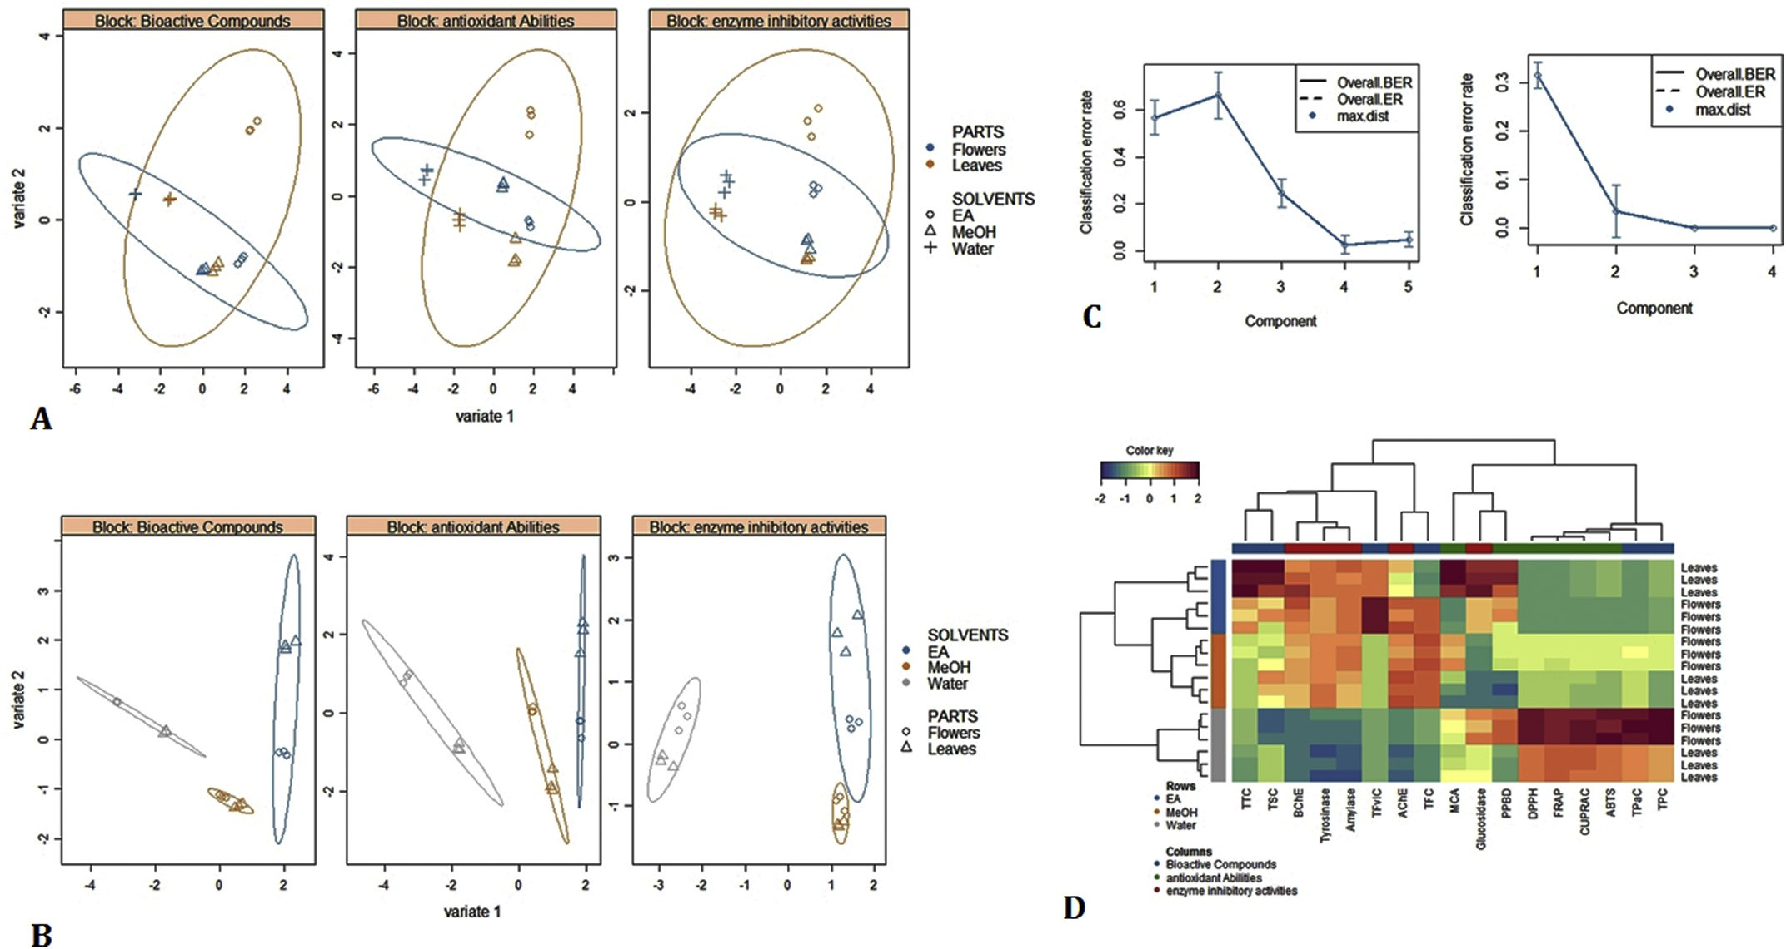
Fig. 1. Supervised multi datasets analysis with DIABLO, A&B: Sample plot with conﬁdence ellipse plots based on the parts of plant and the extracting solvent as class membership criteria respectively, C: prediction model performance per component for Maximum Distance using 5-fold CV repeated 10 times, D: Clustered Image Map (Euclidean Distance, Ward linkage).

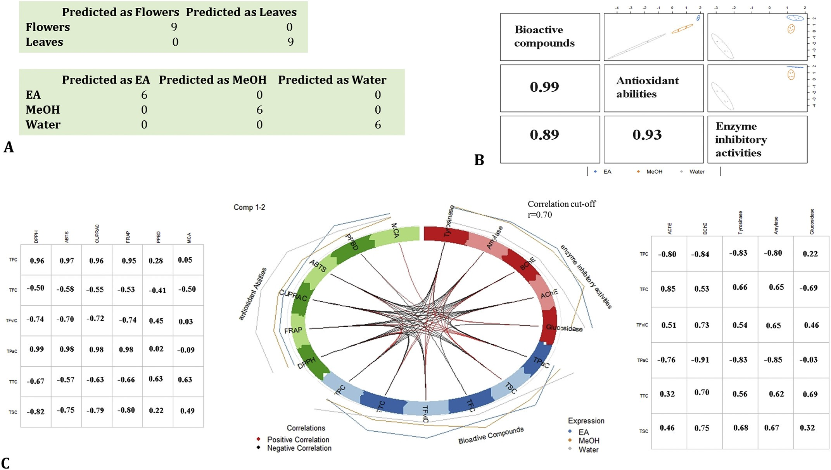
Fig. 2. A: The confusion table for a 4 and 2 component respectively, B: Sample scatterplot displaying the global overview of the correlation between the three data sets at the two ﬁrst component level, C: Circosplot shows the correlation the correlation (r = 0.70) between total bioactive compounds and evaluated biological activities.
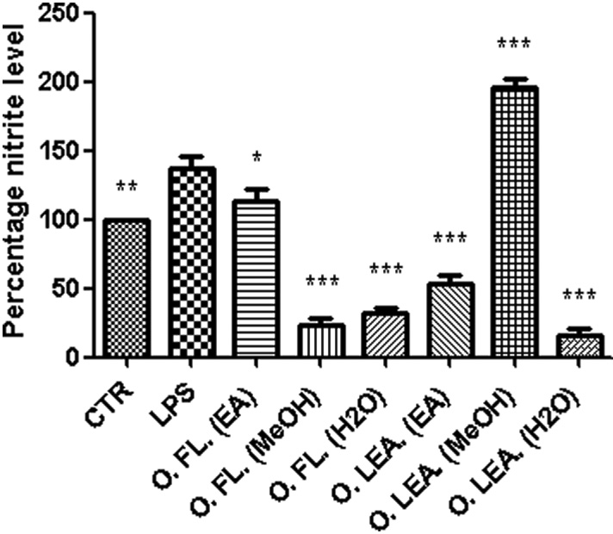
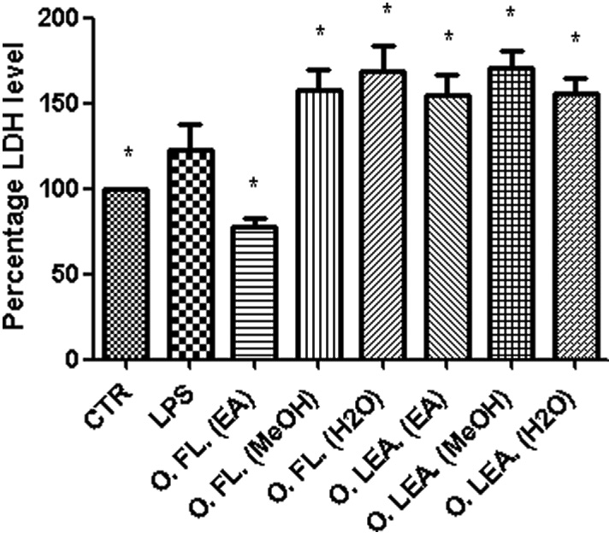

Fig. 3. Eﬀect of water, methanol, and ethyl acetate extracts of Ocimum amer- icanum leaves (O. Lea.) and ﬂowers (O. FL.) (100 μg/mL) on LPS-induced nitrite level in rat colon specimens. ANOVA, p < .0001; post-hoc, *p < .05, ** p < .01, *** p < .001 vs. LPS.

for drug development for the management of type 2 diabetes, Alzhei- mer's disease, and epidermal hyperpigmentation problems. It was noted that a particularly high α-glucosidase inhibition was recorded for the ethyl acetate extract of O. americanum leaves. Quantitative phyto- chemical analysis showed the high concentration of tannins present in
O. americanum leaves ethyl acetate extracts. This ﬁnding is supported by several reports which have described the inhibitory action of some tannins on α-glucosidase (Barrett, Farhadi, & Smith, 2018; Lee, Kim,
Yang, & Sung, 2017; Omar, Li, Yuan, & Seeram, 2012). The eﬃcacy of
O. americanum extracts in inhibiting cholinesterases was also assessed. Cholinesterases inhibitors are regarded as valid therapeutic targets for the management of Alzheimer's disease. Galantamine, a phenanthrene alkaloid of plant origin, possesses neuroprotectant abilities as indicated
Fig. 4. Eﬀect of water, methanol, and ethyl acetate extracts of Ocimum amer- icanum leaves (O. Lea.) and ﬂowers (O. FL.) (100 μg/mL) on LPS-induced LDH activity in rat colon specimens. ANOVA, p < .01; post-hoc, * p < .05 vs. LPS.

by its capacity to inhibit cholinesterase enzymes (Y. Zhang, Zhao, Wu, Chen, & Ma, 2017). However, reports of the Australian Adverse Drug Reaction Advisory Committee described 18 cases of delirium/confu- sion, 8 of syncope, 13 of bradycardia, 6 of other dysrhythmias/con- duction abnormalities, and 6 of hypotension, observed in Alzheimer's patients treated with galantamine, highlighting a dire need for novel compounds (Aagaard, 2014). There is a widespread consensus that AChE is a key enzyme regulating neurotransmission in cholinergic pathways and is an important target in the treatment of neurodegen- erative disorders, such as Alzheimer's disease (Boztas et al., 2019; Atmaka et al., 2019; Genç Bilgiçli et al., 2019). In contrast to the long- established and well-deﬁned role of AChE in the regulation of choli- nergic transmission, the accurate physiological role of BChE remains elusive (Pope & Brimijoin, 2018). Studies have shown that BChE

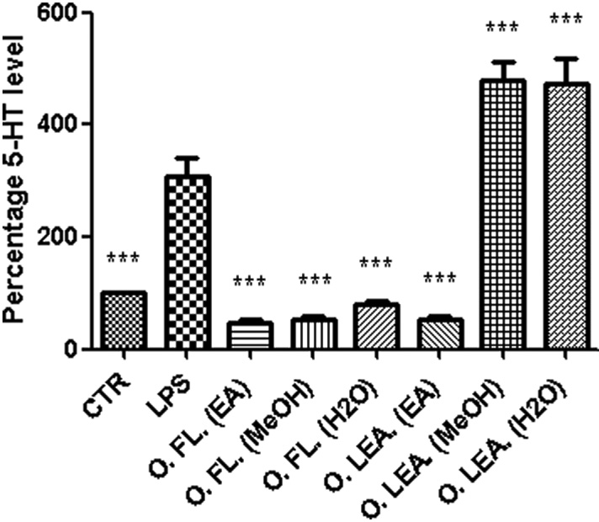
Table 5
Minimum inhibitory concentration (MIC) of plant extracts towards selected bacterial strains.

Fig. 5. Eﬀect of water, methanol, and ethyl acetate extracts of Ocimum amer- icanum leaves (O. Lea.) and ﬂowers (O. FL.) (100 μg/mL) on LPS-induced 5-HT level in rat colon specimens. ANOVA, p < .0001; post-hoc*** p < .001 vs.
LPS.
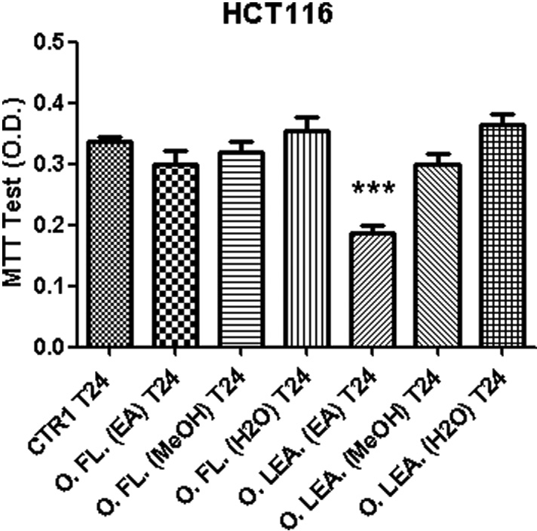
Fig. 6. Eﬀect of water, methanol, and ethyl acetate extracts of Ocimum amer- icanum leaves (O. Lea.) and ﬂowers (O. FL.) (100 μg/mL) on tumoral HCT116 cell line viability (MTT test). ANOVA, p < .0001; post-hoc, *** p < .001 vs. CTR.

Minimum Inhibitory Concentration (MIC)

[mg (dry weight) extract mL⁻¹]ª

Plant part | Extract typology (10:1) | S. aureus | S. Typhimurium
 |  | (ATCC 6538) | (clinical isolate)
 | Ethyl acetate | > 0.2 | > 0.2
 | extract:DMSO
Flowers | Methanol  extract:DMSO | 0.16 (0.1–0.2) | > 0.2
 | Water extract:DMSO | > 0.2 | > 0.2
 | Ethyl acetate:DMSO | > 0.2 | > 0.2
Leaves | Methanol  extract:DMSO | 0.16 (0.1–0.2) | > 0.2
Ciproﬂoxacin^{b} | Water extract:DMSO  – | > 0.2  0.98 | > 0.2  0.49
ª MIC values are reported as geometric means of three independent re- plicates (n = 3); MIC range Concentrations are reported within brackets.
b Ciproﬂoxacin concentration is expressed as μg mL⁻¹.
activity increased in the late stage of Alzheimer's disease. The interac- tion of rosmarinic acid, identiﬁed in the ethyl acetate and methanol extracts of O. americanum leaves and ﬂowers, has been previously de- scribed. The hydroxyl groups rosmarinic acid interacted to the active site of BChE by forming hydrogen bonds with TRP82 and TYR128 re- sidues (Senol et al., 2017). High binding aﬃnity was also observed with AChE (Demirezer et al., 2015). Quercetin and its glycosylated form, rutin, identiﬁed in the active extracts, demonstrated inhibitory action against both cholinesterase enzymes (Ademosun, Oboh, Bello, & Ayeni, 2016). The inhibitory activity observed against AChE and BChE might be related to the concerted action of diﬀerent compounds. Regarding the inhibitory activity against tyrosinase, a signiﬁcant inhibitory eﬀect was recorded for methanol and ethyl acetate extracts of O. americanum leaves and ﬂowers. Tyrosinase inhibition has attracted considerable attention in the management of epidermal hyperpigmentation problems but is also a new target in the management of neurodegenerative complications such as Parkinson's disease. Tyrosinase is a copper-con- taining enzyme crucial in the biosynthesis of melanin, a brown pigment which protects the human skin from UV radiation (Wang, Wang, Xia,

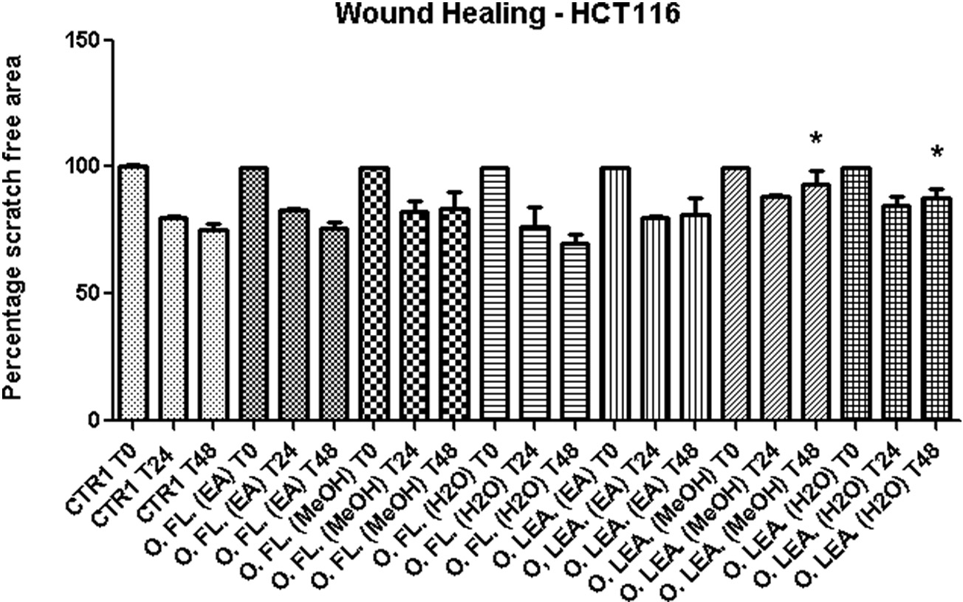
Fig. 7. Eﬀect of water, methanol, and ethyl acetate extracts of Ocimum americanum leaves (O. Lea.) and ﬂowers (O. FL.) (100 μg/mL) on HCT116 migration (Wound healing test). ANOVA, p < .05; post-hoc, *p < .05 vs. respective CTR group.

Table 6
Minimum inhibitory concentration (MIC) of plant extracts towards selected yeasts and ﬁlamentous fungal strains.

Minimum Inhibitory Concentration (MIC) [mg (dry weight) extract mL−1]a

Plant part Extract typology (10:1) C. albicans C. tropicalis

(YEPGA 6183)^{b} (YEPGA 6184)

ethyl acetate extract of O. americanum ﬂower revealed able to blunt LPS-induced LDH, thus suggesting protective eﬀects in the colon. LDH is a well-recognized marker of tissue damage, particularly in the colon. Multiple studies suggested that downregulation of LDH level could be protective mechanism in ulcerative colitis (Kannan & Guruvayoorappan, 2013; Nagarjun, Dhadde, Veerapur, Thippeswamy, & Chandakavathe, 2017).
We also investigated the blunting eﬀect of O. americanum on upre- gulated levels of 5-HT, which plays a key role as pro-inﬂammatory

Ethyl acetate extract:DMSO
Flowers Methanol
extract:DMSO
0.079 (0.05–0.1) 0.079 (0.05–0.1)

0.031 (0.025–0.05) 0.062 (0.05–0.1)
agent in the colon. The role of 5-HT, as colon pro-inﬂammatory cyto- kine, has been previously described (Regmi, Park, Ku, & Kim, 2014) and has been related to 5-HT3 receptor signaling (Mousavizadeh, Rahimian,

Water extract:DMSO 0.16 (0.1–0.2) 0.125 (0.1–0.2)
Fakhfouri, Aslani, & Ghafourifar, 2009). In this context, LPS stimulus

Ethyl acetate extract:DMSO
Leaves Methanol
extract:DMSO
0.079 (0.05–0.1) 0.126 (0.1–0.2)

0.062 (0.05–0.1) 0.079 (0.05–0.1)
was able to increase steady state 5-HT level, in the colon, while anti- oxidant and anti-inﬂammatory extracts revealed eﬀective in blunting 5- HT upregulation induced by inﬂammatory stimulus (Locatelli et al.,

Water extract:DMSO 0.125 (0.1–0.2) > 0.2
Fluconazole – 2 4

ª MIC values are reported as geometric means of three independent re- plicates (n = 3); MIC range concentrations are reported within brackets.
b Fluconazole concentration is expressed as μg mL⁻¹.

Sui, & Si, 2019). However, an excessive production and accumulation of melanin favours the development of epidermal hyperpigmentation problems and dermatological conditions. Additionally, of late tyr- osinase has been related to dopamine neurotoxicity and neurodegen- eration, thereby associating tyrosinase over activity to Parkinson's and other neurodegenerative diseases (Hu et al., 2019). Previous docking studies have shown that quercetin (identiﬁed in O. americanum leaves
and ﬂowers extracts) interacted with the active site of tyrosinase and chelated copper with the 3′, 4′-dihydroxy groups, thus preventing the binding of substrate. Besides, rosmarinic acid has also been reported to inhibit tyrosinase (Fan, Zhang, Hu, Xu, & Gong, 2017; Kang, Kim, Byun, Park, & Cho, 2004). The intricate synergism operating between the
compounds could be responsible for the observed inhibition.
In the present study, a pharmaco-toxicological investigation was performed, as well, in order to conﬁrm the intrinsic antioxidant eﬀects, but also to investigate potential applications of O. americanum leaf and ﬂower extracts, through a multidirectional approach, in vitro. Firstly, we explored the range of biocompatibility with a toxicological model constituted by brine shrimp (A. salina), which is commonly used to investigate a variety of biological and toxicological activities of plant extracts and is considered, at least partially, predictive of cytotoxicity (Ferrante et al., 2019; Ohikhena, Wintola, & Afolayan, 2016). The calculated LC₅₀ was indicatory to select the extract concentration
(100 μg/mL) for the subsequent biological studies.
Particularly, antioxidant/anti-inﬂammatory eﬀects of O. amer- icanum extracts were investigated on isolated rat colon fragments sti- mulated with LPS, an ex vivo paradigm reproducing the burden of in- ﬂammatory and oxidative stress occurring in ulcerative colitis (Locatelli et al., 2017; Menghini et al., 2016; Menghini et al., 2018). Increased reactive oxygen (ROS) and nitrogen species (RNS) have long been re- lated to tissue damage through the onset of disruptive peroxidation reactions of nucleic acids, proteins, and lipids (Gülçin, 2012; Uttara, Singh, Zamboni, & Mahajan, 2009). To this regard, lipid peroxidation plays a key role in ulcerative colitis (Achitei et al., 2013).The mea- surement of nitrite level is regarded as a tool to evaluate nitrosative stress, which is strictly related to lipid peroxidation, particularly in ulcerative colitis (Goggins et al., 2001).
It was observed that all O. americanum extracts, except the leaf
methanol extract, were able to blunt the upregulation of colon nitrite level induced by LPS (Fig. 3). Regarding LDH level assessment, ex- perimental data showed that most of the O. americanum extracts were ineﬀective. Additionally, extract supplementation in tissue medium enhanced LPS-induced LDH level in isolate colon (Fig. 4). Only the
2017; Menghini et al., 2016). The evaluation of neurotransmitter tissue level has long been considered as a reliable assessment of neuro- transmitter synthesis and release (Bungo, Shiraishi, Yanagita, Ohta, & Fujita, 2009; Clark, MohanKumar, Kasturi, & MohanKumar, 2006). Concerning 5-HT level, ﬂower extracts, together with ethyl acetate extract of O. americanum leaves inhibited LPS-induced 5-HT level (Fig. 5). The blunting eﬀects induced by these extracts on the selected biomarkers could be related to ﬂavonoid-induced inhibitory eﬀects on LDH, 5-HT3 receptor and i-NOS, whose upregulation has been causally related to inﬂammatory conditions and tissue damage (Chandel, Rawal, & Kaur, 2018; He et al., 2018; Herbrechter et al., 2015; Mousavizadeh et al., 2009; Zhang et al., 2018). On the other hand, water and methanol extract of O. americanum leaves, despite showing signiﬁcant amounts of total phenols and ﬂavonoids (Table 1), enhanced LPS-induced 5-HT level, thus indicating pro-inﬂammatory eﬀects with potential tissue damages, as also suggested by the concomitant increase of LDH levels (Fig. 4). Nevertheless, recent ﬁndings by Abnosi and Yari (2018) highlighted the potential toxicity of gallic acid in rat bone marrow mesenchymal stem cells, partially related to increased inﬂammatory and oxidative stress mediators, including LDH.
The eﬀect of O. americanum extracts on viability (MTT test) and
spontaneous migration (wound healing test) of human colon cancer HCT116 cell line was also investigated. Consistent with the inhibition of pro-oxidant and pro-inﬂammatory biomarker level in the colon, the antiproliferative eﬀect induced by ethyl acetate extract of O. amer- icanum ﬂower conﬁrmed its role as protective agent in rat colon (Fig. 6). Conversely, the stimulation of HCT116 wound healing process could account for an increase in migration and invasion capacities of this cell line, thus further suggesting a potential toxicity induced by water and methanol extracts of O. americanum leaves (Fig. 7). Con- sidering that LDH may stimulate cell migration through mitochondrial ROS production (Valvona, Fillmore, Nunn, & Pilkington, 2016), in- creased HCT116 migration following treatment with water and me- thanol extract of O. americanum leaves could be related to the observed stimulation of LDH level in the colon.
Finally, the inhibitory eﬀects of O. americanum extracts on bacteria
and fungi, which potentially contribute in ulcerative colitis, have been studied (Cho & Chae, 2004; Guo et al., 2015; Iguidbashian, Parekh, Kukrety, & Andukuri, 2018; Trojanowska et al., 2010; Wang et al., 2018). O. americanum extracts were eﬀective against both S. aureus and
S. Typhimurium (Table 5). The same extracts also inhibited C. albicans and C. tropicalis (Table 6). Actually, the inhibitory eﬀects exerted by O. americanum extracts on the selected bacteria and fungi strains is con- sistent with extract total content in phenols and ﬂavonoids (Bottari et al., 2017; de Camargo et al., 2017). These ﬁndings, besides corro- borating to the preliminary observations by Thaweboon and Thaweboon (2009) about antibacterial and antifungal eﬀects of O. americanum essential oil, further claims that this species might be considered as potential and innovative source of antibacterial and an- tifungal compounds.

Scientiﬁc data collected from the present investigation supported that the leaves and ﬂowers of O. americanum contain several classes of secondary metabolites which might be responsible for the observed biological activities. Our ﬁndings also highlighted the inﬂuence of solvent choice on the extraction yield of secondary metabolites from plants. The water extracts of the leaves and ﬂowers of O. americanum demonstrated high radical scavenging and reducing activity. In general,
the extracts of O. americanum were poor inhibitor of α-amylase and
potent α-glucosidase inhibitor. The methanol and ethyl acetate extracts of O. americanum exhibited highest inhibition against acet-
ylcholinesterase, butyrylcholinesterase, and tyrosinase. On the other hand, toxicological assays indicated a potential toxicity of the methanol and water extracts of O. americanum leaves. Conversely, ethyl acetate extracts displayed the best toxicological proﬁle, exhibiting both anti- inﬂammatory and antiproliferative eﬀects in the colon. All the extracts revealed to be eﬀective antimicrobial agents, thus suggesting potential applications in the isolation of antibacterial and antifungal compounds. Future investigations should focus on the determination of the biolo- gical activity of isolated phytochemicals from the leaves and ﬂowers of
O. americanum, in order to elucidate the mechanisms of action sub- stantiating the observed eﬀects.

Acknowledgements

This work was supported by grants from the Italian Ministry of University (FAR 2018 granted to Prof. Claudio Ferrante; FAR 2017 granted to Giustino Orlando; FAR 2016 granted to Luigi Menghini; FAR 2014 granted to Lucia Recinella). Animal experimental procedure were approved by Italian Ministry of Health (authorization N. F4738.N.XTQ, delivered on 11th November 2018).

References

Aagaard, L. (2014). Central nervous system stimulants and drugs that suppress appetite. In J. K. Aronson (Vol. Ed.), Side eﬀects of drugs annual. Vol. 35. Side eﬀects of drugs annual (pp. 1–25). Elsevier.
Achitei, D., Ciobica, A., Balan, G., Gologan, E., Stanciu, C., & Stefanescu, G. (2013).
Diﬀerent proﬁle of peripheral antioxidant enzymes and lipid peroxidation in active and non-active inﬂammatory bowel disease patients. Digestive Diseases and Sciences, 58(5), 1244–1249.
Ademosun, A. O., Oboh, G., Bello, F., & Ayeni, P. O. (2016). Antioxidative properties and
eﬀect of quercetin and its glycosylated form (rutin) on acetylcholinesterase and bu- tyrylcholinesterase activities. Journal of Evidence-Based Complementary & Alternative Medicine, 21(4), 11–17.
Adomako-Bonsu, A. G., Chan, S. L. F., Pratten, M., & Fry, J. R. (2017). Antioxidant activity
of rosmarinic acid and its principal metabolites in chemical and cellular systems: Importance of physico-chemical characteristics. Toxicology In Vitro, 40, 248–255.
Aluko, B. T., Oloyede, O. I., & Afolayan, A. J. (2013). Polyphenolic contents and free radical scavenging potential of extracts from leaves of Ocimum americanum L. Pakistan Journal of Biological Sciences, 16, 22–30.
Angers, P., Morales, M. R., & Simon, J. E. (1996). Fatty acid variation in seed oil among
Ocimum species. Journal of the American Oil Chemists' Society, 73(3), 393–395.
Atmaca, U., Kaya, R., Karaman, H. S., Çelik, M., & Gülçin, I. (2019). Synthesis of ox- azolidinone from enantiomerically enriched allylic alcohols and determination of their molecular docking and biologic activities. Bioorganic Chemistry, 88, 102980.
Barrett, A. H., Farhadi, N. F., & Smith, T. J. (2018). Slowing starch digestion and in- hibiting digestive enzyme activity using plant ﬂavanols/tannins— A review of eﬃ- cacy and mechanisms. LWT-Food Science and Technology, 87, 394–399.
Bassole, I. H. N., Nebie, R., Savadogo, A., Ouattara, C. T., Barro, N., & Traore, S. A. (2005). Composition and antimicrobial activities of the leaf and ﬂower essential oils of Lippia chevalieri and Ocimum canum from Burkina Faso. African Journal of
Biotechnology, 4(10), 1156–1160.
Berhow, M. A., Aﬀum, A. O., & Gyan, B. A. (2012). Rosmarinic acid content in anti- diabetic aqueous extract of Ocimum canum sims grown in Ghana. Journal of Medicinal Food, 15(7), 611–620.
Bottari, N. B., Lopes, L. Q. S., Pizzuti, K., dos Santos Alves, C. F., Corrêa, M. S., Bolzan, L.
P., ... Santos, R. C. (2017). Antimicrobial activity and phytochemical characterization of Carya illinoensis. Microbial Pathogenesis, 104, 190–195.
Boztas, M., Taslimi, P., Yavari, M. A., Gülçin, I., Sahin, E., & Menzek, A. (2019). Synthesis and biological evaluation of bromophenol derivatives with cyclopropyl moiety: Ring opening of cyclopropane with monoester. Bioorganic Chemistry, 89, 103017.
Brunetti, L., Orlando, G., Ferrante, C., Recinella, L., Leone, S., Chiavaroli, A., ... Vacca, M. (2014). Peripheral chemerin administration modulates hypothalamic control of feeding. Peptides, 51, 115–121.
Bungo, T., Shiraishi, J.-I., Yanagita, K., Ohta, Y., & Fujita, M. (2009). Eﬀect of nociceptin/
orphanin FQ on feeding behavior and hypothalamic neuropeptide expression in layer-type chicks. General and Comparative Endocrinology, 163(1–2), 47–51.
de Camargo, A. C., Regitano-d'Arce, M. A. B., Rasera, G. B., Canniatti-Brazaca, S. G., do Prado-Silva, L., Alvarenga, V. O., ... Shahidi, F. (2017). Phenolic acids and ﬂavonoids of peanut by-products: Antioxidant capacity and antimicrobial eﬀects. Food
Chemistry, 237, 538–544.
Cerretani, L., & Bendini, A. (2010). Rapid assays to evaluate the antioxidant capacity of phenols in virgin olive oil. In V. R. Preedy, & R. R. Watson (Eds.). Olives and olive oil in health and disease prevention (pp. 625–635). San Diego: Academic Press.
Chandel, P., Rawal, R. K., & Kaur, R. (2018). Natural products and their derivatives as
cyclooxygenase-2 inhibitors. Future Medicinal Chemistry, 10(20), 2471–2492.
Charan, J., & Kantharia, N. (2013). How to calculate sample size in animal studies?
Journal of Pharmacology & Pharmacotherapeutics, 4(4), 303.
Cho, W.-S., & Chae, C. (2004). Expression of cyclooxygenase-2 and nitric oxide synthase 2 in swine ulcerative colitis caused by Salmonella Typhimurium. Veterinary Pathology, 41(4), 419–423.
Clark, K. A., MohanKumar, S. M., Kasturi, B. S., & MohanKumar, P. (2006). Eﬀects of
central and systemic administration of leptin on neurotransmitter concentrations in speciﬁc areas of the hypothalamus. American Journal of Physiology-Regulatory, Integrative and Comparative Physiology, 290(2), 306–312.
Dash, A. K., Mishra, J., & Dash, D. K. (2014). Antidiabetic activity and modulation of
antioxidant status by Ocimum canum in streptozotocin-induced diabetic rats. European Scientiﬁc Journal, 10(6), 168–177.
Demirezer, L. O., Gurbuz, P., Kelicen Ugur, E. P., Bodur, M., Ozenver, N., Uz, A., & Guvenalp, Z. (2015). Molecular docking and ex vivo and in vitro anticholinesterase activity studies of Salvia sp. and highlighted rosmarinic acid. Turkish Journal of Medicinal Science, 45(5), 1141–1148.
Dirar, A. I., Alsaadi, D. H. M., Wada, M., Mohamed, M. A., Watanabe, T., & Devkota, H. P.
(2019). Eﬀects of extraction solvents on total phenolic and ﬂavonoid contents and biological activities of extracts from Sudanese medicinal plants. South African Journal of Botany, 120, 261–267.
Dzoyem, J. P., McGaw, L. J., Kuete, V., & Bakowsky, U. (2017). Anti-inﬂammatory and
anti-nociceptive activities of African medicinal spices and vegetables. In V. Kuete (Ed.). Medicinal spices and vegetables from Africa (pp. 239–270). Academic Press.
Ekundayo, O., Laakso, I., & Hiltunen, R. (1989). Constituents of the volatile oil from leaves of Ocimum canum Sims. Flavour and Fragrance Journal, 4, 17–18.
Fan, M., Zhang, G., Hu, X., Xu, X., & Gong, D. (2017). Quercetin as a tyrosinase inhibitor: Inhibitory activity, conformational change and mechanism. Food Research International, 100(1), 226–233.
Ferrante, C., Orlando, G., Recinella, L., Leone, S., Chiavaroli, A., Di Nisio, C., ... Brunetti,
L. (2016). Central inhibitory eﬀects on feeding induced by the adipo-myokine irisin.
European Journal of Pharmacology, 791, 389–394.
Ferrante, C., Recinella, L., Ronci, M., Menghini, L., Brunetti, L., Chiavaroli, A., ... Orlando,
G. (2019). Multiple pharmacognostic characterization on hemp commercial cultivars: Focus on inﬂorescence water extract activity. Food and Chemical Toxicology, 125, 452–461.
Genç Bilgiçli, H., Kestane, A., Taslimi, P., Karabay, O., Bytyqi-Damoni, A., Zengin, M., &
Gulçin, İ. (2019). Novel eugenol bearing oxypropanolamines: Synthesis, character- ization, antibacterial, antidiabetic, and anticholinergic potentials. Bioorganic Chemistry, 88, 102931.
Goggins, M. G., Shah, S. A., Goh, J., Cherukuri, A., Weir, D. G., Kelleher, D., & Mahmud,
N. (2001). Increased urinary nitrite, a marker of nitric oxide, in active inﬂammatory bowel disease. Mediators of Inﬂammation, 10(2), 69–73.
Gülçin, İ. (2012). Antioxidant activity of food constituents: An overview. Archives of
Toxicology, 86(3), 345–391.
Gülçin, I., Elmastaş, M., & Aboul-Enein, H. Y. (2007). Determination of antioxidant and radical scavenging activity of Basil (Ocimum basilicum L. Family Lamiaceae) assayed
by diﬀerent methodologies. Phytotherapy Research, 21(4), 354–361.
Gülçin, İ., Scozzafava, A., Supuran, C. T., Koksal, Z., Turkan, F., Çetinkaya, S., ... Alwasel,
S. H. (2016). Rosmarinic acid inhibits some metabolic enzymes including glutathione S-transferase, lactoperoxidase, acetylcholinesterase, butyrylcholinesterase and car- bonic anhydrase isoenzymes. Journal of Enzyme Inhibition and Medicinal Chemistry, 31(6), 1698–1702.
Guo, M., Ding, S., Zhao, C., Gu, X., He, X., Huang, K., ... Xu, W. (2015). Red Ginseng and
Semen Coicis can improve the structure of gut microbiota and relieve the symptoms of ulcerative colitis. Journal of Ethnopharmacology, 162, 7–13.
He, W., Li, Y., Liu, M., Yu, H., Chen, Q., Chen, Y., ... Wang, T. (2018). Citrus aurantium L. and its ﬂavonoids regulate TNBS-induced inﬂammatory bowel disease through anti- inﬂammation and suppressing isolated jejunum contraction. International Journal of Molecular Sciences, 19(10), 3057.
Herbrechter, R., Ziemba, P. M., Hoﬀmann, K. M., Hatt, H., Werner, M., & Gisselmann, G. (2015). Identiﬁcation of Glycyrrhiza as the rikkunshito constituent with the highest

antagonistic potential on heterologously expressed 5-HT3A receptors due to the ac- tion of ﬂavonoids. Frontiers in Pharmacology, 6, 130.
Hu, S., Wang, T., Zou, J., Zhou, Z., Lu, C., Nie, J., ... Wang, F. (2019). Highly chemose- lective ﬂuorescent probe for the detection of tyrosinase in living cells and zebraﬁsh model. Sensors and Actuators B: Chemical, 283, 873–880.
Iguidbashian, J. P., Parekh, J. D., Kukrety, S., & Andukuri, V. G. (2018). Campylobacter
jejuni and Pseudomonas coinfection in the setting of ulcerative colitis. BMJ Case Reports, 2018, 1–4 (bcr-2018-224941).
Ju, J., Kwak, Y., Hao, X., & Yang, C. S. (2012). Inhibitory eﬀects of calcium against intestinal cancer in human colon cancer cells and ApcMin/+ mice. Nutrition Research and Practice, 6(5), 396–404.
Kang, H. S., Kim, H.-R., Byun, D. S., Park, H. J., & Cho, J. S. (2004). Rosmarinic acid as a
tyrosinase inhibitors from Salvia miltiorrhiza. Natural Product Sciences, 10(2), 80–84.
Kannan, N., & Guruvayoorappan, C. (2013). Protective eﬀect of Bauhinia tomentosa on acetic acid induced ulcerative colitis by regulating antioxidant and inﬂammatory mediators. International Immunopharmacology, 16(1), 57–66.
Krzyzowska, M., Tomaszewska, E., Ranoszek-Soliwoda, K., Bien, K., Orlowski, P.,
Celichowski, G., & Grobelny, J. (2017). Tannic acid modiﬁcation of metal nano- particles: possibility for new antiviral applications. In E. Andronescu, & A. M. Grumezescu (Eds.). Nanostructures for oral medicine (pp. 335–363). Elsevier.
Lê Cao, K.-A., Boitard, S., & Besse, P. (2011). Sparse PLS discriminant analysis:
Biologically relevant feature selection and graphical displays for multiclass problems.
BMC Bioinformatics, 12(1), 253.
Lee, D. Y., Kim, H. W., Yang, H., & Sung, S. H. (2017). Hydrolyzable tannins from the fruits of Terminalia chebula Retz and their α-glucosidase inhibitory activities.
Phytochemistry, 137, 109–116.
Leﬀers, A. (2003). Gemsbok Bean & Kalahari Truﬄe: Traditional plant use by Jul'hoansi in North-Eastern Namibia. Windhoek, Namibia: Gamsberg Macmillan Publishers.
Locatelli, M., Ferrante, C., Carradori, S., Secci, D., Leporini, L., Chiavaroli, A., ...
Menghini, L. (2017). Optimization of aqueous extraction and biological activity of
Harpagophytum procumbens root on ex vivo rat colon inﬂammatory model.
Phytotherapy Research, 31(6), 937–944.
Madhiyazhagan, P., Murugan, K., Kumar, A. N., & Nataraj, T. (2014). Extraction of mosquitocidals from Ocimum canum leaves for the control of dengue and malarial vectors. Asian Paciﬁc Journal of Tropical Disease, 4, S549–S555.
Menghini, L., Ferrante, C., Leporini, L., Recinella, L., Chiavaroli, A., Pintore, G., ...
Brunetti, L. (2016). An hydroalcoholic chamomile extract modulates inﬂammatory and immune response in HT29 cells and isolated rat colon. Phytotherapy Research, 30(9), 1513–1518.
Menghini, L., Leporini, L., Vecchiotti, G., Locatelli, M., Carradori, S., Ferrante, C., ...
Orlando, G. (2018). Crocus sativus L. stigmas and byproducts: qualitative ﬁngerprint, antioxidant potentials and enzyme inhibitory activities. Food Research International, 109, 91–98.
Mousavizadeh, K., Rahimian, R., Fakhfouri, G., Aslani, F., & Ghafourifar, P. (2009). Anti-
inﬂammatory eﬀects of 5-HT3 receptor antagonist, tropisetron on experimental co- litis in rats. European Journal of Clinical Investigation, 39(5), 375–383.
Nagarjun, S., Dhadde, S. B., Veerapur, V. P., Thippeswamy, B., & Chandakavathe, B. N. (2017). Ameliorative eﬀect of chromium-d-phenylalanine complex on indomethacin- induced inﬂammatory bowel disease in rats. Biomedicine & Pharmacotherapy, 89, 1061–1066.
Nyarko, A. K., Asare-Anane, H., Ofosuhene, M., & Addy, M. E. (2002). Extract of Ocimum
canum lowers blood glucose and facilitates insulin release by isolated pancreatic β- islet cells. Phytomedicine, 9(4), 346–351.
Ohikhena, F. U., Wintola, O. A., & Afolayan, A. J. (2016). Toxicity assessment of diﬀerent solvent extracts of the medicinal plant, Phragmanthera capitata (Sprengel) Balle on Brine Shrimp (Artemia salina). International Journal of Pharmacology, 12, 701–710.
Omar, R., Li, L., Yuan, T., & Seeram, N. P. (2012). alpha-Glucosidase inhibitory hydro-
lyzable tannins from Eugenia jambolana seeds. Journal of Natural Products, 75(8), 1505–1509.
Oyedemi, S. O., Oyedemi, B. O., Coopoosamy, R. M., Prieto, J. M., Stapleton, P., & Gibbons, S. (2017). Antibacterial and norﬂoxacin potentiation activities of Ocimum americanum L. against methicillin resistant Staphylococcus aureus. South African
Journal of Botany, 109, 308–314.
Pandey, R., Chandra, P., Kumar, B., Dutt, B., & Sharma, K. R. (2016). A rapid and highly sensitive method for simultaneous determination of bioactive constituents in leaf extracts of six Ocimum species using ultra high performance liquid chromatography- hybrid linear ion trap triple quadrupole mass spectrometry. Analytical Methods, 8,
333–341.
Phiwchai, I., Yuensook, W., Sawaengsiriphon, N., Krungchanuchat, S., & Pilapong, C. (2018). Tannic acid (TA): A molecular tool for chelating and imaging labile iron. European Journal of Pharmaceutical Sciences, 114, 64–73.
Pope, C. N., & Brimijoin, S. (2018). Cholinesterases and the ﬁne line between poison and
remedy. Biochemical Pharmacology, 153, 205–216.
Regmi, S. C., Park, S.-Y., Ku, S. K., & Kim, J.-A. (2014). Serotonin regulates innate im- mune responses of colon epithelial cells through Nox2-derived reactive oxygen spe- cies. Free Radical Biology and Medicine, 69, 377–389.
Sarma, D. S. K., & Babu, A. V. S. (2011). Pharmacognostic and phytochemical studies of
Ocimum americanum. Journal of Chemical and Pharmaceutical Research, 3(3),
337–347.
Sen, S. K., & Behera, L. M. (2008). Ethnomedicinal plants used by the tribals of Bargarh
district to cure diarrhoea and dysentery. Indian Journal of Traditional Knowledge, 7(3), 425–428.
Senol, F. S., Ślusarczyk, S., Matkowski, A., Pérez-Garrido, A., Girón-Rodríguez, F., Cerón- Carrasco, J. P., ... Orhan, I. E. (2017). Selective in vitro and in silico butyr- ylcholinesterase inhibitory activity of diterpenes and rosmarinic acid isolated from
Perovskia atriplicifolia Benth. and Salvia glutinosa L. Phytochemistry, 133, 33–44.
Shah, A., & Rahim, S. (2017). Ethnomedicinal uses of plants for the treatment of malaria in Soon Valley, Khushab, Pakistan. Journal of Ethnopharmacology, 200, 84–106.
Silva, L. D. L., Garlet, Q. I., Koakoski, G., Abreu, M. S. D., Mallmann, C. A., Baldisserotto,
B., ... Heinzmann, B. M. (2015). Anesthetic activity of the essential oil of Ocimum americanum in Rhamdia quelen (Quoy & Gaimard, 1824) and its eﬀects on stress parameters. Neotropical Ichthyology, 13(4), 715–722.
Sunitha, K., & Begum, N. (2013). Immunomodulatory activity of methanolic extract of
Ocimum americanum seeds. International Journal of Research in Pharmacy and Chemistry, 3(1), 95–98.
Tamil Selvi, M., Thirugnanasampandan, R., & Sundarammal, S. (2015). Antioxidant and cytotoxic activities of essential oil of Ocimum canum Sims. from India. Journal of Saudi Chemical Society, 19(1), 97–100.
Tenenhaus, A., Philippe, C., Guillemot, V., Le Cao, K.-A., Grill, J., & Frouin, V. (2014).
Variable selection for generalized canonical correlation analysis. Biostatistics, 15(3), 569–583.
Thaweboon, S., & Thaweboon, B. (2009). In vitro antimicrobial activity of Ocimum americanum L. essential oil against oral microorganisms. The Southeast Asian Journal of Tropical Medicine and Public Health, 40(5), 1025–1033.
Topal, M., & Gulҫin, I. (2014). Rosmarinic acid: a potent carbonic anhydrase isoenzymes
inhibitor. Turkish Journal of Chemistry, 38(5), 894–902.
Trojanowska, D., Zwolinska-Wcislo, M., Tokarczyk, M., Kosowski, K., Mach, T., & Budak,
A. (2010). The role of Candida in inﬂammatory bowel disease. Estimation of trans- mission of C. albicans fungi in gastrointestinal tract based on genetic aﬃnity between strains. Medical Science Monitor, 16(10), CR451–CR457.
Upadhyay, R. K., Misra, L. N., & Singh, G. (1991). Sesquiterpene alcohols of the copane
series from essential oil of Ocimum americanum. Phytochemistry, 30(2), 691–693. Uttara, B., Singh, A. V., Zamboni, P., & Mahajan, R. (2009). Oxidative stress and neu-
rodegenerative diseases: A review of upstream and downstream antioxidant ther- apeutic options. Current Neuropharmacology, 7(1), 65–74.
Uysal, S., Zengin, G., Locatelli, M., Bahadori, M. B., Mocan, A., Bellagamba, G., ...
Aktumsek, A. (2017). Cytotoxic and enzyme inhibitory potential of two Potentilla species (P. speciosa L. and P. reptans Willd.) and their chemical composition. Frontiers in Pharmacology, 8, 290.
Valvona, C. J., Fillmore, H. L., Nunn, P. B., & Pilkington, G. J. (2016). The regulation and function of lactate dehydrogenase a: therapeutic potential in brain tumor. Brain Pathology, 26(1), 3–17.
Vidhani, S. I., Vyas, V. G., Parmar, H. J., Bhalani, V. M., Hassan, M. M., Gaber, A., &
Golakiya, B. A. (2016). Evaluation of some chemical composition, minerals fatty acid proﬁles, antioxidant and antimicrobial activities of Tulsi (Ocimum sanctum) from India. American Journal of Food Science and Technology, 4(2), 52–57.
Vieira, R. F., Grayer, R. J., & Paton, A. J. (2003). Chemical proﬁling of Ocimum amer-
icanum using external ﬂavonoids. Phytochemistry, 63(5), 555–567.
Wang, R., Wang, G., Xia, Y., Sui, W., & Si, C. (2019). Functionality study of lignin as a tyrosinase inhibitor: Inﬂuence of lignin heterogeneity on anti-tyrosinase activity. International Journal of Biological Macromolecules, 128, 107–113.
Wang, X., Tian, G., Duan, Q., Wu, D., Shao, J., Wang, T., & Wang, C. (2018). Therapeutic
potential of n-butanol extract of Pulsatilla decoction in a murine model of ulcerative colitis induced by DSS combined with Candida albicans colonization. China Journal of Chinese Materia Medica, 43(14), 2979–2984.
Wold, H. (1966). Estimation of principal components and related models by iterative least
squares. Multivariate Analysis, 391–420.
Zengin, G., & Aktumsek, A. (2014). Investigation of antioxidant potentials of solvent extracts from diﬀerent anatomical parts of Asphodeline anatolica E. Tuzlaci: an en-
demic plant to Turkey. African Journal of Traditional, Complementary and Alternative Medicines, 11(2), 481–488.
Zengin, G., Locatelli, M., Stefanucci, A., Macedonio, G., Novellino, E., Mirzaie, S., ...
Mollica, A. (2017). Chemical characterization, antioxidant properties, anti-in-
ﬂammatory activity, and enzyme inhibition of Ipomoea batatas L. leaf extracts.
International Journal of Food Properties, 20(sup2), 1907–1919.
Zengin, G., Uysal, A., Diuzheva, A., Gunes, E., Jekő, J., Cziáky, Z., ... Mahomoodally, M. F. (2018). Characterization of phytochemical components of Ferula halophila extracts using HPLC-MS/MS and their pharmacological potentials: A multi-functional insight.
Journal of Pharmaceutical and Biomedical Analysis, 160, 374–382.
Zhang, W., Dong, Z., Chang, X., Zhang, C., Rong, G., Wang, C., ... Lu, Y. (2018). Protective eﬀect of the total ﬂavonoids from Apocynum venetum L. on carbon tetrachloride-in- duced hepatotoxicity in vitro and in vivo. Journal of Physiology and Biochemistry,
74(2), 301–312.
Zhang, Y., Zhao, L., Wu, Z., Chen, X., & Ma, T. (2017). Galantamine alleviates senescence of U87 cells induced by beta-amyloid through decreasing ROS production.
Neuroscience Letters, 653, 183–188.

